A336-Eur-Bulgaria-Odessos-Thracian Rider Plaque-Marble-4th century BCE

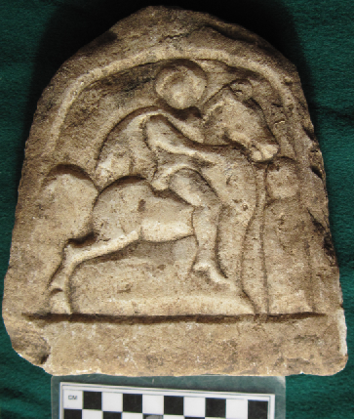

Fig. 1. Thracian Rider Plaque from Odessos-Marble-4th century BCE. The rider as a divine psychopomp with a halo signifying his divinity, is approaching a newly deceased who is wrapped in linen shrouds, who is about to be carried away to the Hereafter.

Case No.: 4

Accession Number: A336

Formal Label: Odessos-Thracian Rider Plaque-Marble-4th century BCE

**Display Description:**

The Thracian Rider cult is known from 4th century Greek and Latin inscriptions that describe him as "the hero" (*o ἥρως*, *o hḗrōs*), which is linked to the Thracian term for "the hero," *o *ierus*, or *o *iarus*. The demonstrative article is important for its suggests an importance that elevates the epithet. Hence, the Thracian Rider as *o ἥρως* was a divinity on the same level as the Greek mythic *o ἥρως* (Detschew 1957: 200) and he was even called ο μεγάλος θεός (megalos theos*,* "great god"), being identified on the same level with Asclepius, Apollo, Dionysus and Silvanus.

This Thracian Rider Plaque from Odessos dating to the 4th century BCE shows the rider as a divine psychopomp with a halo signifying his divinity. He is approaching a newly deceased who is wrapped in linen shrouds, who is about to be carried away to the Hereafter. This plaque invokes the Rider’s rôle as *ο σωτήρας* ("savior").

LC Classification:  DF261.T6

Date or Time Horizon: 4th century BCE

Geographical Area: west coast, Black Sea

Map

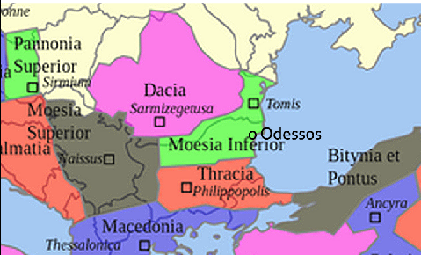

GPS Coordinates: [43°13′N 27°55′E](https://tools.wmflabs.org/geohack/geohack.php?pagename=Varna&params=43_13_N_27_55_E_region:BG_type:city(335177))

Cultural Affiliation: Thrace

Geographical Area: Moesia Inferior

Medium: Marble

**Dimensions**: H 166.50 mm, 6.56 in  
**Weight: 980 g, 2 lb 2.5 oz**

**Provenance**: Odessos

**Condition:** original

**Discussion:**

The cult was particularly influential in Thrace, Dacia and in Moesia Inferior on the western shore of the Black Sea (modern Romania and Bulgaria) during the 2nd and 3rd centuries CE where he became associated with the hero of the Getae mystery religion of Dacia, which diffused among Roman legions after 106 CE, when Trajan conquered Dacia and made it a Roman province.

**References:**

Alexandrescu, Petre. "L'oiseau unicorne, Introduction à l'iconologie thrace." *Comptes rendues de l'Académie d'Inscriptions et Belles Lettres* (1993): 725–745.

Anon. 1992. "Heros Equitans." In *Lexicon Iconographicum Mythologiae Classicae* (*LIMC)*, vol. 6, 1–2. Zürich and Munich, pp. 1019–1081.

Condurachi, Emile. "A propos de la genèse de l'iconographie du cavalier thrace." In *Mythologie gréco-romaine. Mythologies périphériques*, pp. 63–69. Paris, 1981.

Detschew, Dimiter. 1957. *Die thrakischen Sprachreste*. Vienna.

Dimitrova, Nora. "Inscriptions and Iconography in the Monuments of the Thracian Rider." *Hesperia* 71 (2002): 209–229

Gočeva, Zlatozara. "Les traits caractéristiques de l'iconographie du cavalier thrace." In *Iconographie classique et identités régionales*, pp. 237–243. Paris, 1986.

Hampartumian, Nubar. 1979. *Corpus Cultus Equitis Thracii*, vol. 4, *Moesia Inferior (Romanian Section) and Dacia*/ Leiden.

Hoddinott, Ralf F. 1992. "The Thracian Hero at Rogozen." In *Studia Aegaea et Balcanica in Honorem Lodovicae Press*, pp. 157–165. Warsaw.

Kazarow, Gawrill I. 1938. *Die Denkmäler des thrakischen Reitergottes in Bulgarien*, 2 vols. Budapest.

Sanie, Silvin. 1989. "Kulte und Glauben im römischen Süden der Moldau (Ostrumänien)." In *Aufstieg und Niedergang der römischen Welt I*, vol. II, 18, 2. Berlin and New York, 1989, pp. 1272–1316.

Tudor, Dumitru. 1969–1976. *Corpus monumentorum religionis equitum Danuvinorum*, 2 vols. (Leiden,). Volume 1, *The Monuments*, translated by Eve Harris and John R. Harris; volume 2, *The Analysis and Interpretation of the Monuments*, translated by Christopher Holme,

Walter, Christopher.1989. "The Thracian Horseman." *Byzantinischen Forschungen* 14: 657–673.